Project Initialization and Planning Phase

Date | 21-sep-2026
Team ID | MCA(Master of Computer Application)
Project Name | Online Learning Engagement and Student Performance Analysis
Maximum Marks | 4 Marks

Define Problem Statements :

Create a problem statement to understand your student's point of view. The student Problem Statement template helps you focus on what matters to create experiences people will love. A well-articulated student problem statement allows you and your team to find the ideal solution for your student' challenges. Throughout the process, you’ll also be able to empathize with your student, which helps you better understand how they perceive your product or service.

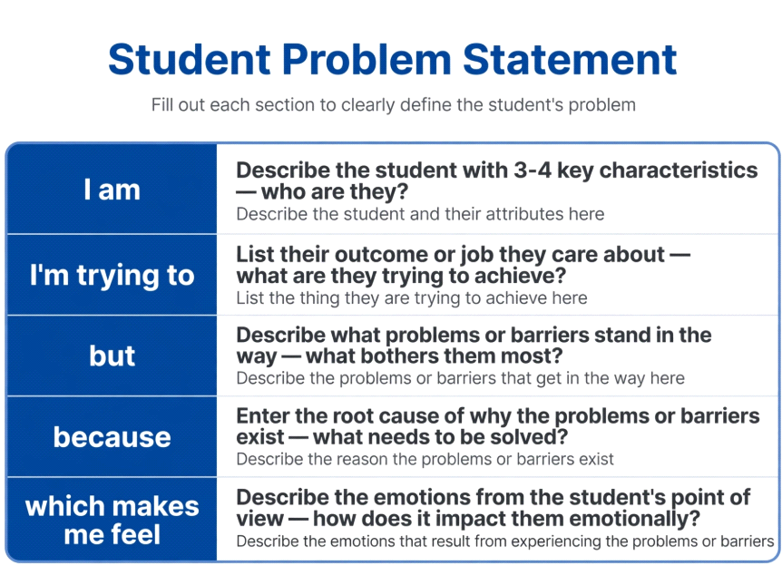

Example:
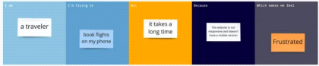

Problem  Statement (PS) | I am  (Student) | I’m trying to | But | Because | Which makes me feel
PS-1 | An academic administrator overseeing an online learning program | understand which students are actively engaged and performing well versus those at risk of failing or dropping out | there is no consolidated, real-time view of student engagement (clicks) and performance (scores) across the platform | the data is scattered across spreadsheets and not visualized in a way that highlights patterns or flags at-risk students | overwhelmed and reactive, unable to intervene until it is too late
PS-2 | a program coordinator responsible for reducing student dropout rates | identify which factors most affect student dropout and pass rates | I cannot easily compare performance and engagement trends across student segments (region, gender, education level, risk level) | there is no interactive dashboard, only raw data that requires manual filtering and analysis to interpret | frustrated and limited in my ability to make timely, data-driven decisions to support students

